# [**Christopher Meloni Reveals How Elliot Stabler Will Have Changed in Law & Order: Organized Crime**](https://www.tvguide.com/amp/news/christopher-meloni-elliot-stabler-changed-in-law-order-organized-crime/?__twitter_impression=true&s=09)

MountainsBY [**SADIE GENNIS**](https://www.tvguide.com/authors/sadie-gennis/)[**@SADIEGENNIS**](https://www.twitter.com/sadiegennis)JUL 29, 2020 10:26 AM EDT

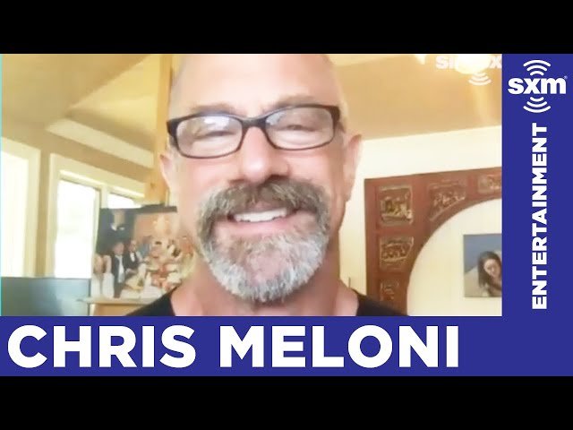

Elliot Stabler ([**Christopher Meloni**](https://www.tvguide.com/celebrities/christopher-meloni/144798/)) is returning to the NYPD — and our screens — this fall in a new [***Law & Order: SVU***](https://www.tvguide.com/tvshows/law-order-special-victims-unit/100257/)spin-off, *Law & Order: Organized Crime.* During an interview on *The Jess Cagle Show*, Christopher Meloni shared a few details about how Stabler will have grown since viewers last saw him nine years ago.

"I always thought of Elliot, as flawed as he may have been, I think his heart was always in the right place. I think it was his sense of injustice that just brought out the worst aspects of him. I think age, mellowing — maybe not in his passions, but in how he went about doing his job," Meloni said of how Stabler will have changed. "He has evolved. I think he's in a good place now with his family. I think he's in a much better place with himself, vis a vis the world."

Meloni starred on *SVU* for the NBC procedural's first twelve seasons but was abruptly written out without a proper onscreen goodbye after the actor chose to leave the show. His character's absence was explained by having Stabler retire from the NYPD rather than agree to undergo a full review by Internal Affairs following a lethal shooting in the SVU squad room.

[**Everything We Know About Elliot Stabler Spin-Off *Law & Order: Organized Crime***](https://www.tvguide.com/news/christopher-meloni-elliot-stabler-law-order-svu-spin-off/)

In addition to explaining how *Organized Crime* will address Stabler's previous struggles with anger management and bending (or in some cases breaking) the law by portraying a more evolved version of the character, Meloni shared that the show will also address the issues that are built directly into the criminal justice system. As daily protests against police brutality and systemic racism continue, Meloni said that *Organized Crime* will explore the truths about policing today.

"I think he's going to be coming back into the world — I think as we're all experiencing right now — [the world] has really changed with policing and citizenry. It's a new day and there are new ways of going about things. I think those are all issues to be addressed in the show and I think it's going to be a challenge for Elliot. One that I think he's going to meet."

*Law & Order: Organized Crime* will air Thursdays on NBC this fall.

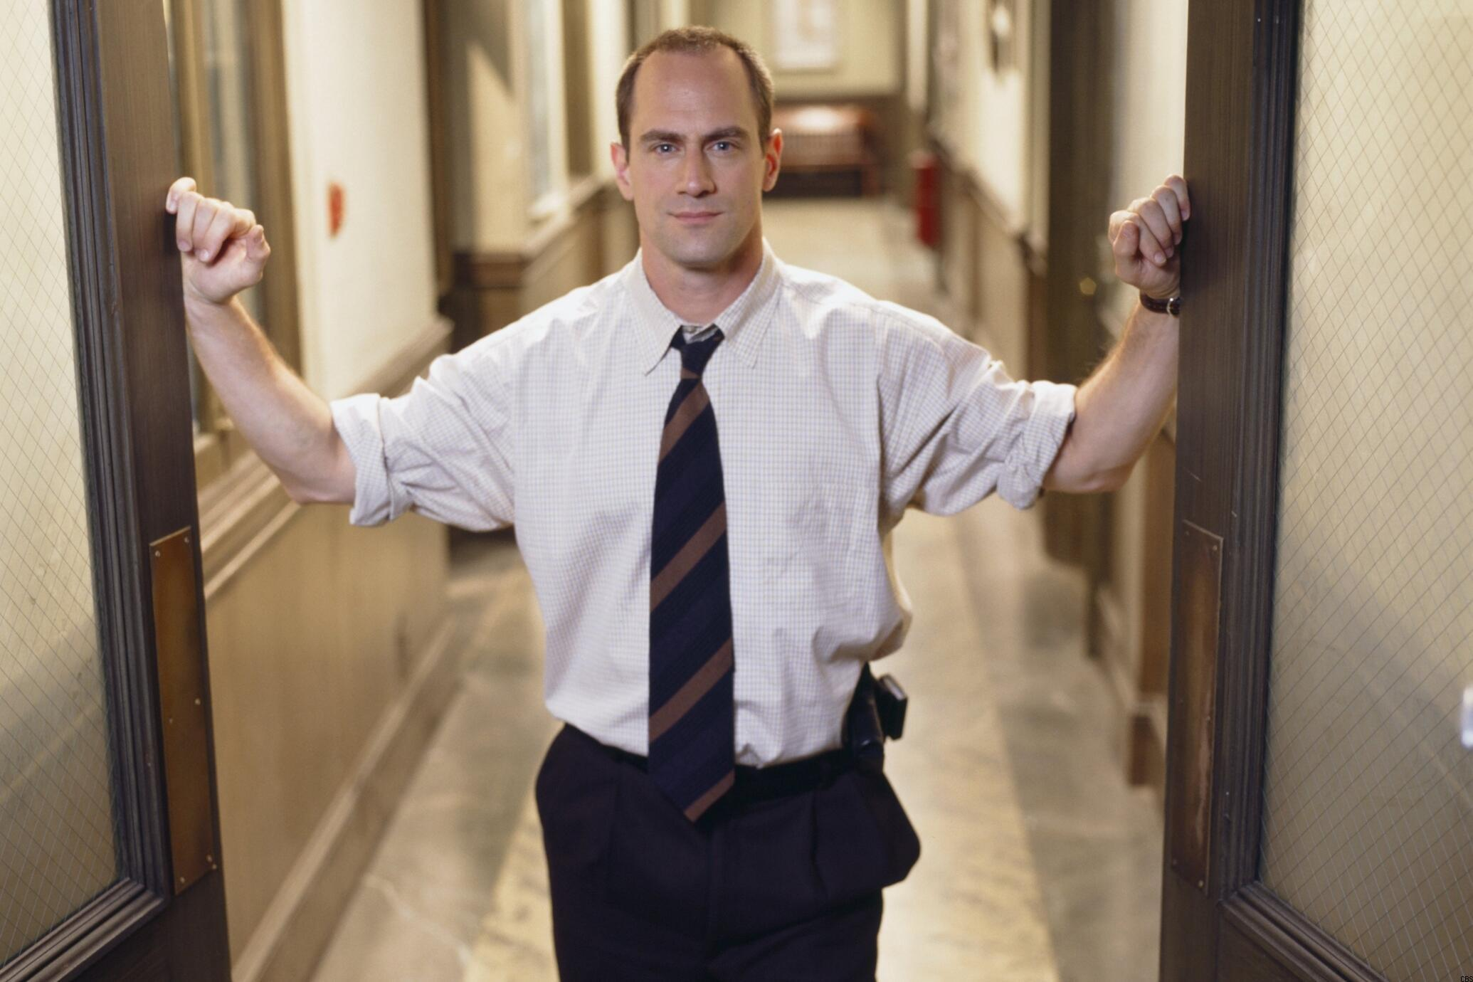 Christopher Meloni

(*Disclosure: TV Guide is owned by CBS Interactive, a division of ViacomCBS.*)